Using The CSS Grid Layout Activity (60:00)

#### **Learning Outcome Addressed**

 4. Apply CSS styles to create web page layouts

### CSS Grid Layout

CSS Grid Layout is a great addition to a developer's "toolbox" as it allows you to build web page layouts in new and interesting ways.

CSS Grid Layout is a grid system that defines rows and columns on a web page, making it easier to design clean and concise web page layouts. It is used commonly in industry, and as such, its important that you use it.

While you could achieve this layout without using CSS grid, this activity is assessing your use of grid. To get started, it is recommended to use a couple of specific methods:

* [grid-area](https://developer.mozilla.org/en-US/docs/Web/CSS/grid-area)
* grid-template-columns, and,
* grid-template-rows.

_You can checkout this [documentation](https://developer.mozilla.org/en-US/docs/Web/CSS/CSS_Grid_Layout) to learn more about the CSS Grid Layout concepts_

**Your task in this activity is to design the following layout using CSS Grid Layout:**

[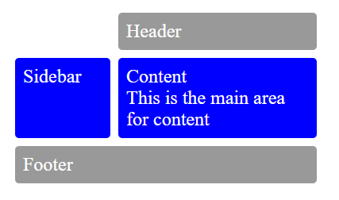](https://cdn.filestackcontent.com/RwqD9WvRQgaroEG9ASTv)

Hint:

* The starter files *index.html* and *styles.css* already contain the HTML elements needed for this design along with some styles
* The column track in the *wrapper* element style should have a width of 120px

Task

Edit the styles.css file to create a page layout that matches the given design.

<!DOCTYPE html>

<html>

<head>

    <link rel="stylesheet" href="./styles.css">

</head>

<body id="main">

    <div class="wrapper">

        <div class="box header">Header</div>

        <div class="box sidebar">Sidebar</div>

        <div class="box content">Content

            <br /> This is the main area for content</div>

        <div class="box footer">Footer</div>

    </div>

</body>

</html>

body {

  margin: 40px;

}

.sidebar {

  /* TODO: Define the grid area here */

}

.content {

  /* TODO: Define the grid area here */

}

.header {

  /* TODO: Define the grid area here */

}

.footer {

  /* TODO: Define the grid area here */

}

.wrapper {

  display: grid;

  grid-gap: 10px;

  background-color: #fff;

  color: #444;

  /* TODO: Define the grid-template-columns and grid-template-areas values here. */

  grid-template-columns: 120px 120px 120px;

  grid-template-areas:

    '....... header header'

    'sidebar content content'

    'footer  footer  footer';

}

.box {

  background-color: #0000ff;

  color: #fff;

  border-radius: 5px;

  padding: 10px;

  font-size: 150%;

}

.header,

.footer {

  background-color: #999;

}